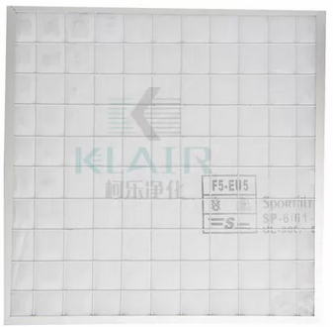

**G1 Low Resistant Flat Panel Air Filter Particle Air Filter For HVAC Application**

**General Description:**

**Pre Filter**, Media Holding Frame type use light-weight aluminum frame and internal reinforced steel rib, which can re-useable to save the cost. The medium can be washable 2-3 times with great low pressure drop and flammability F1 class. Medium Change is quite easy for normal user.

The medium thickness available in 5mm, 10mm, 15mm and 20mm, these fluffy synthetic medium ensure a great dust holding capacity.

**Main Features:**

* Washable medium;
* Great dust holidng capacity than normal pleat pre filter;
* F1 flammability and low pressure drop;
* Wide range of efficiency G2-M5;
* Simple structure for easy medium change;
* Robust structure, okay use in complicated condition.

**Parameters:**

* Media: Fluffy Synthetic fiber
* Frame: Light-weight Aluminum
* Efficiency: G2,G3,G4,M5
* Average Arrestance:  72%, 82%, 92%, 95%
* Initial resistance: 45 Pa
* Recommended final pressure drop : 250Pa
* Humidity resistance: 90%RH
* Max Temperature: 80 ℃
* DIN 53438 Flammability: F1
* UL 900 Standard :  Class 2
* Max.air flow rate:  125% of rated air flow
* Media color available: White
* Filter standard depth available 2 inch(46mm) and 4 inch(96mm)